https://admin.microsoft.com
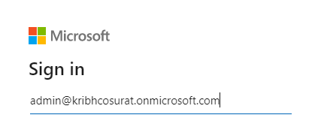
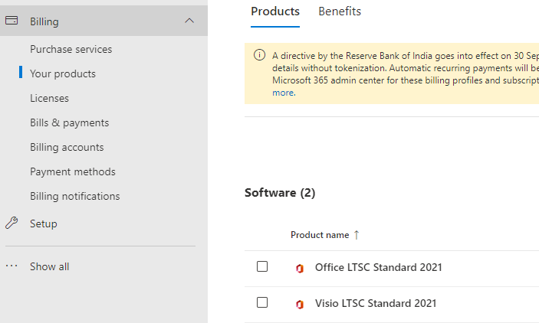
This ID is created for recently & purchased above two software products.

https://www.microsoft.com/Licensing/servicecenter/default.aspx
User : adminplant@kribhco.net

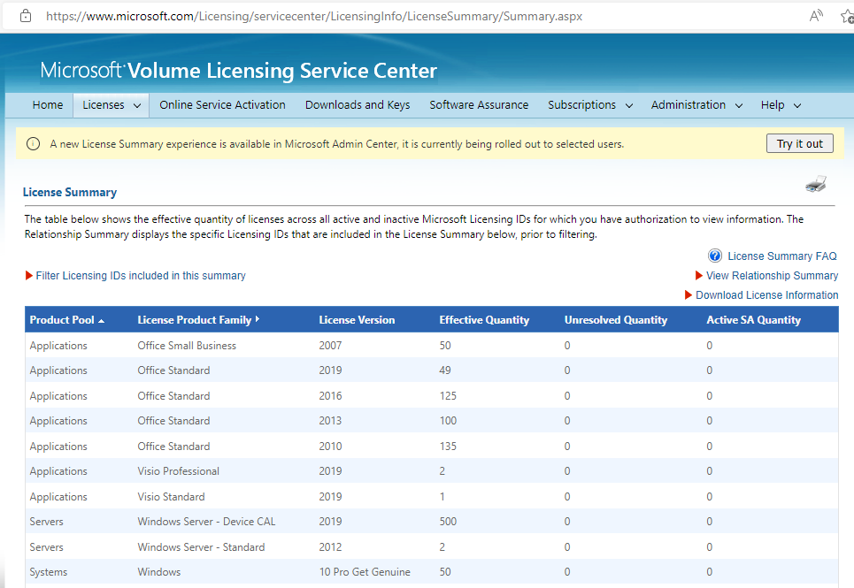

https://admin.microsoft.com
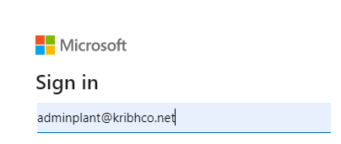
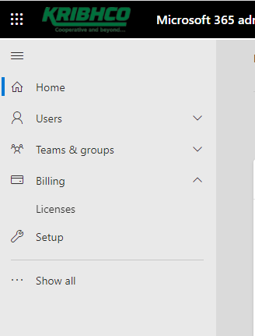

Our requirement is to show all the previous (adminplant@kribhco.net) and latest procurement (admin@kribhcosurat.onmicrosoft.com) licenses under Single tenant ID “adminplant@kribhco.net” for all Microsoft products which are procured by KRIBHCO.

adminplant@kribhco.onmicrosoft.com

vasunilkumar@kribhco.net

hemantkumarsuppal
hemant@softprimetech.com
94111 35888
SoftPrime Technologies Pvt Ltd

